**Formative Assignment __**

|  |  |
| --- | --- |
| Module Name | Web Development Using Platforms |
| Course Name | Bachelor’s Degree in Software Engineering |
| Assignment Title | Import Users Into Liferay and Give Access Rights |

|  |  |
| --- | --- |
| Learner Name | Francis Roel L. Abarca |

|  |
| --- |
| Learner declaration |
| I certify that the work submitted for this assignment is my own and research sources are fully acknowledged.  Student signature: Date: 3/16/23 |

**Trainer--- University training, SSG training,**

**Content development**

**Scope of this assignment**

1. Log in as a Portal Administrator, Create a new role for "Moderator" and define permission to manage all the contents of "Online News Portal". (Other administrator roles are already defined in Liferay Portal.)
2. Create three users and assign the relevant role to all users.
3. Check different access rights between Administrator, site administrator, and Moderator

**Task Wise Solutions**

1. Log in as a Portal Administrator, Create a new role for "Moderator" and define permission to manage all the contents of "Online News Portal". (Other administrator roles are already defined in Liferay Portal.)  
     
   - Inside Roles, click on the + icon.  
   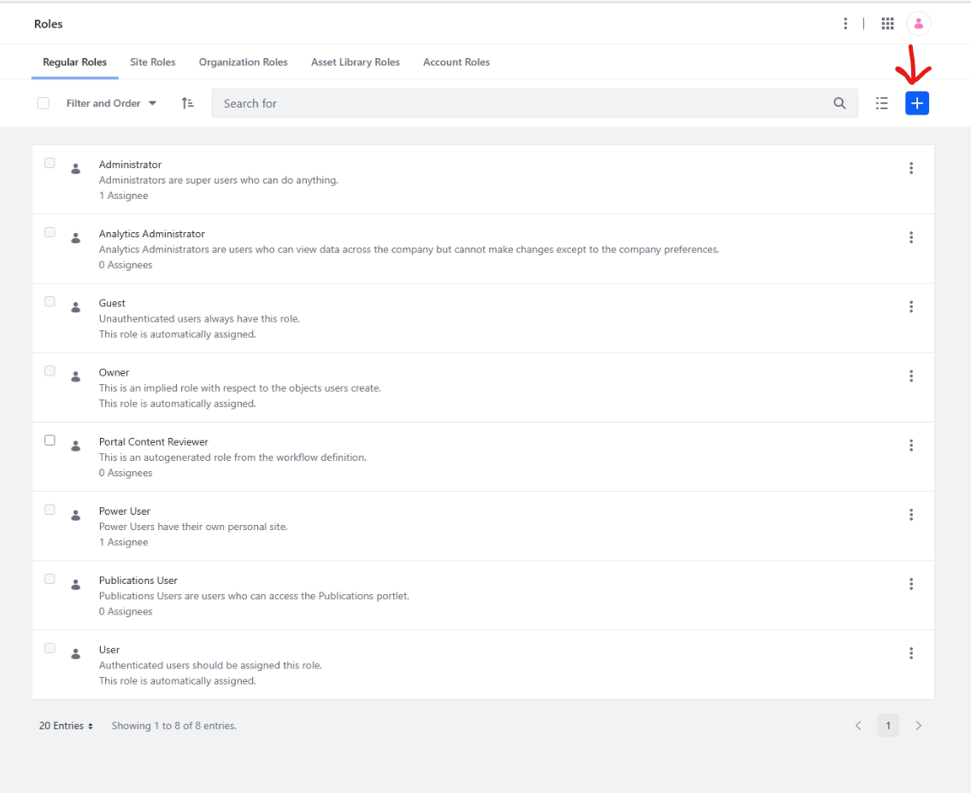

- Create your Moderator role  
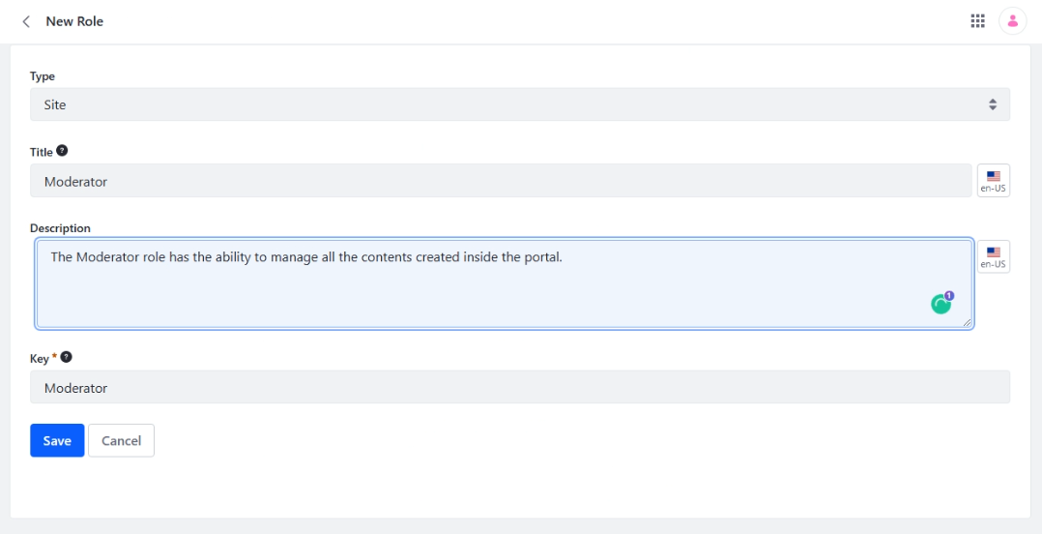

- After that, go to Define Permissions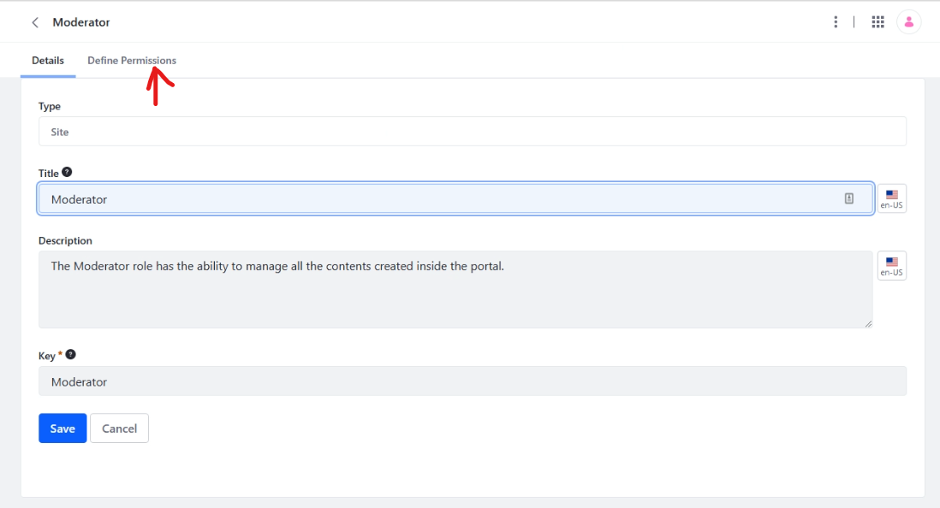

- Set these following permissions for Moderator.  
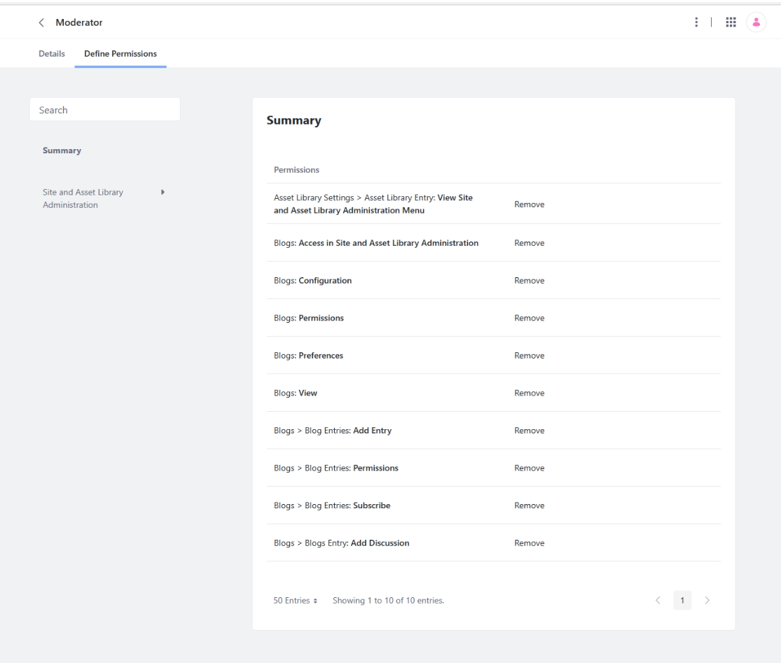

- Save and go back, then go to Site Roles and there goes your Moderator role.  
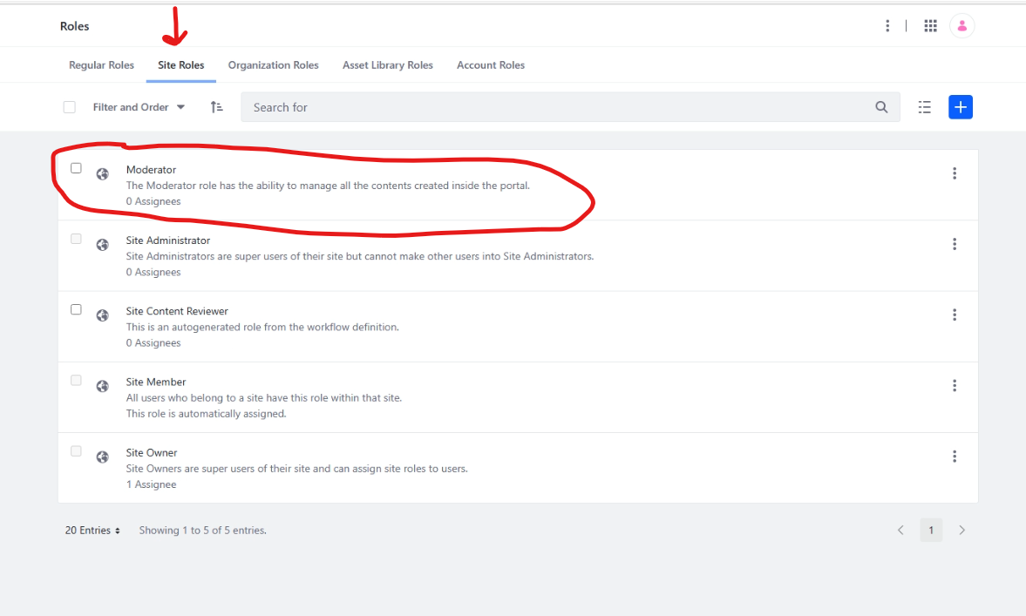

1. Create three users and assign the relevant role to all users.  
   - Site Administrator (Dimple)  
    - Go to Users and Organizations then click on the + button  
   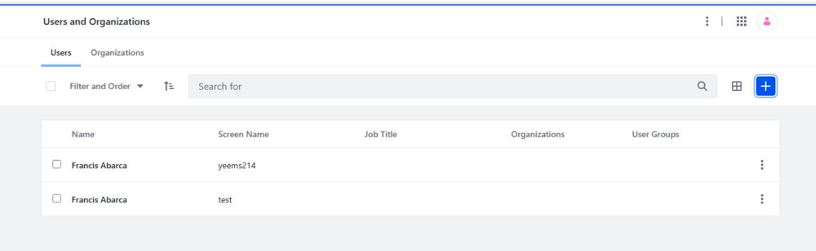

- Enter the information for this specific user.  
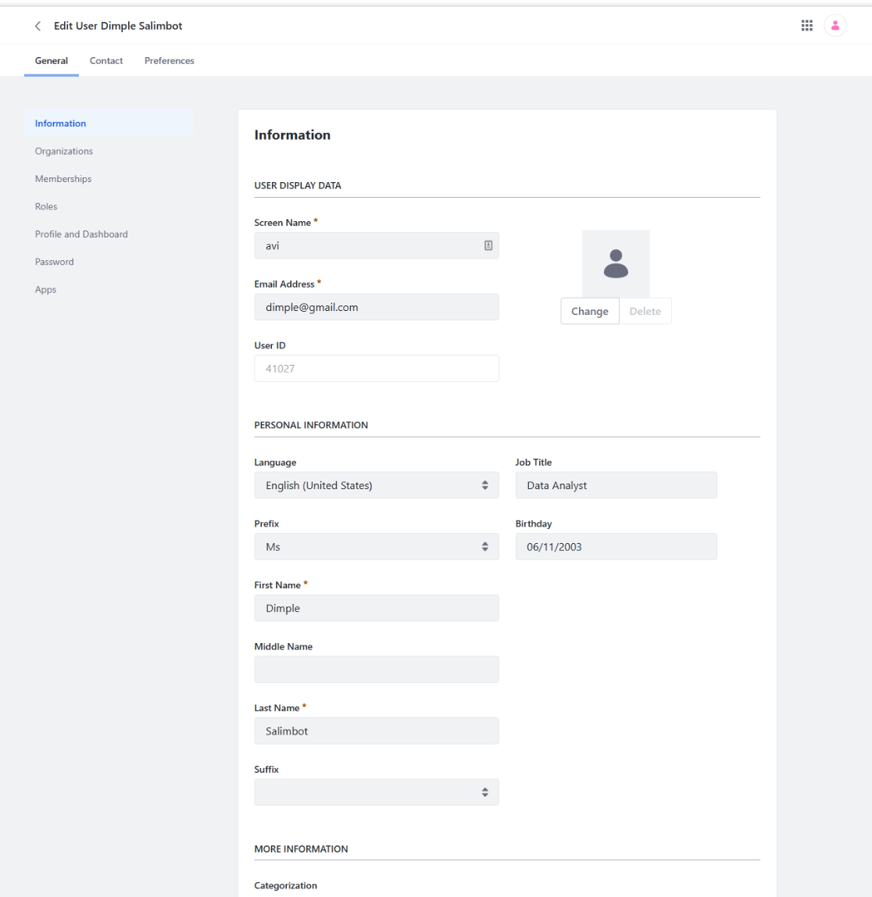  
- Go to Memberships then assign the user to its designated site and save.  
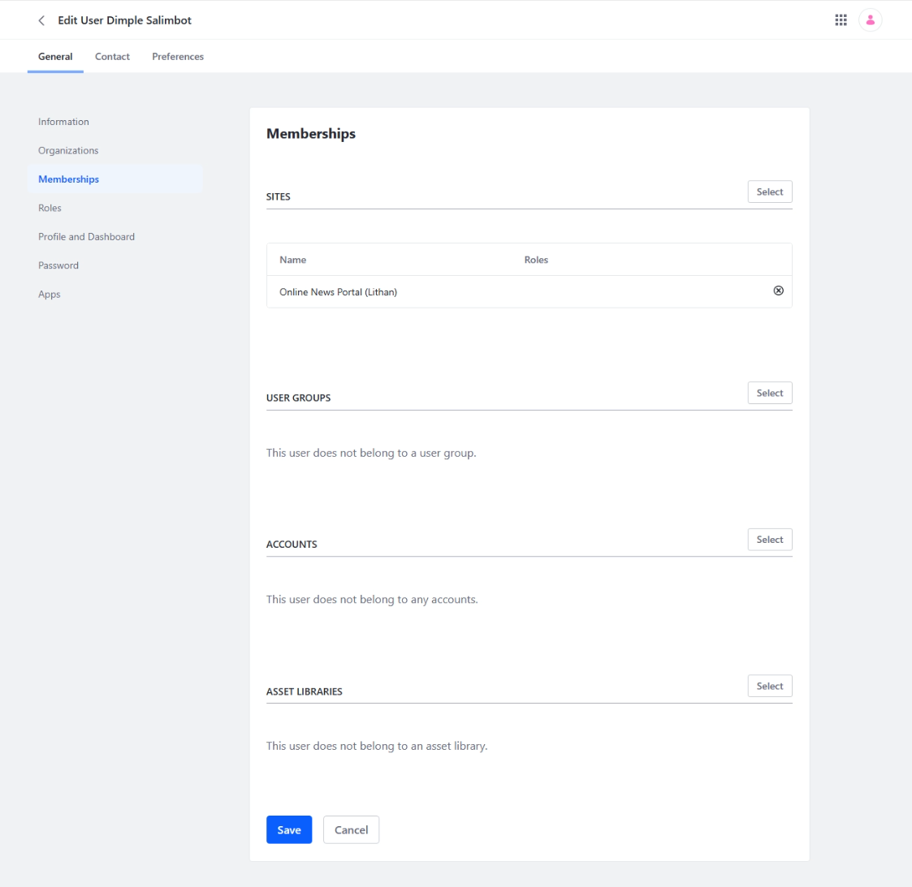

- Go to Roles then inside Site Roles, click Select and set it to Site Administrator.  
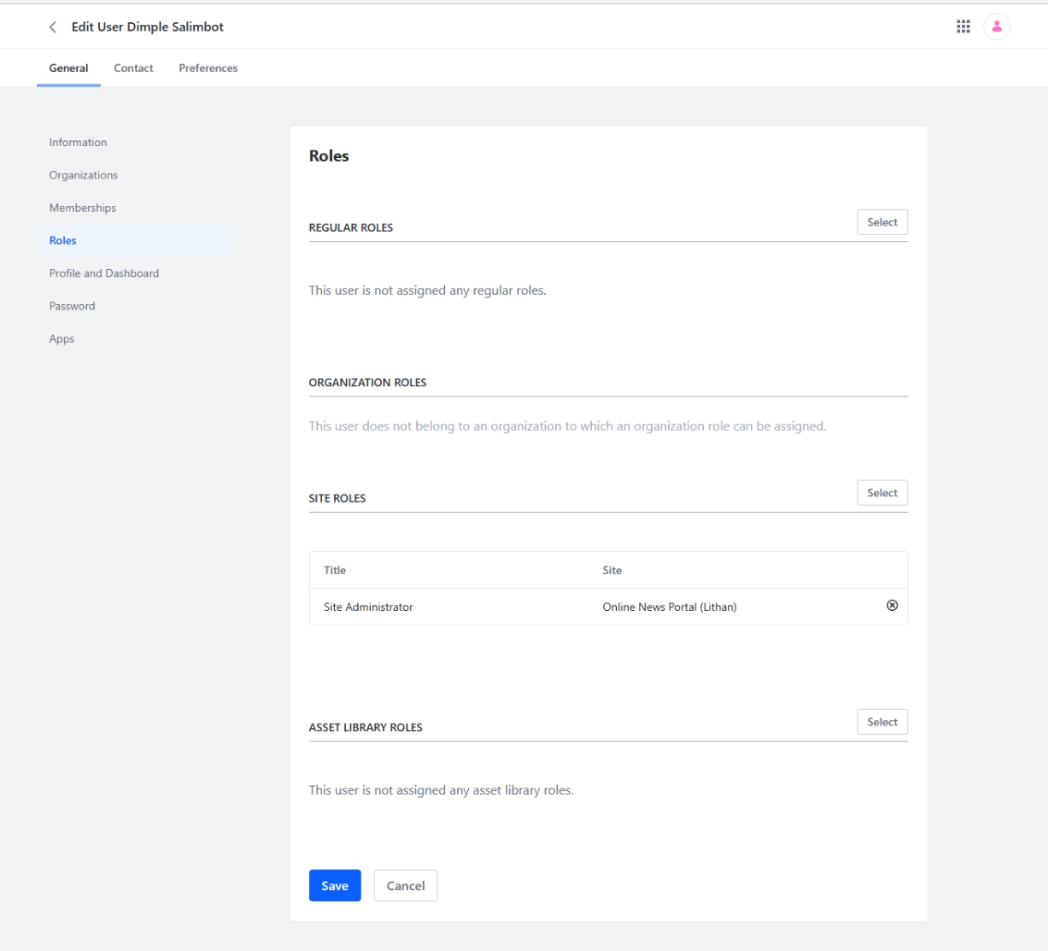

Moderator (Kervin)

- Add a new account then enter the information for the specific user.  
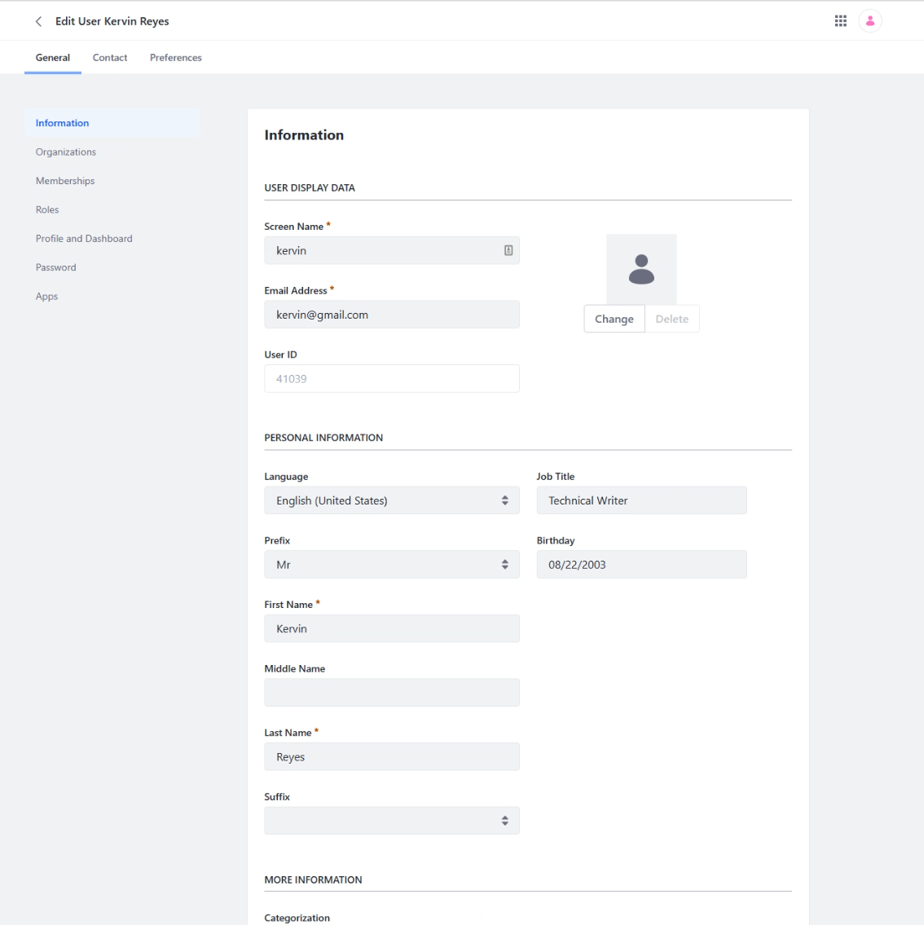

- Go to Memberships then assign this user to the site. 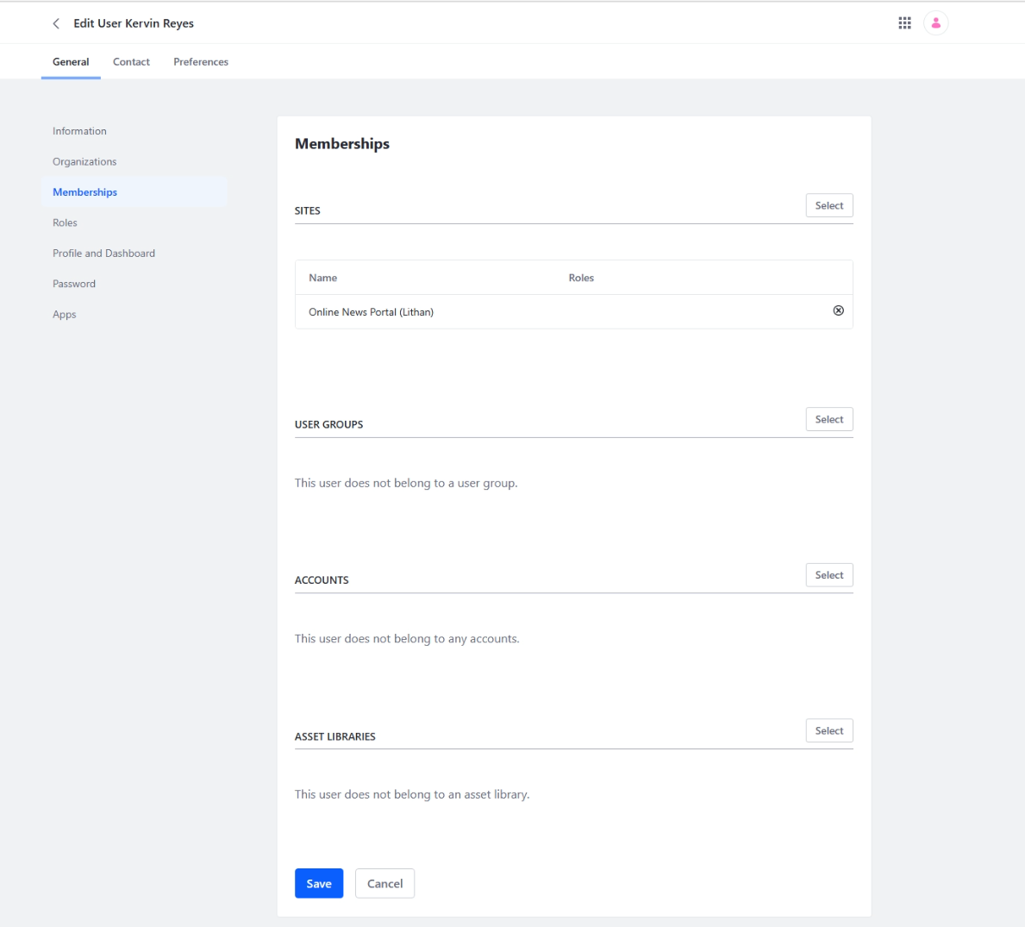

- Go to Roles then inside Site Roles, click Select and set it to Moderator. 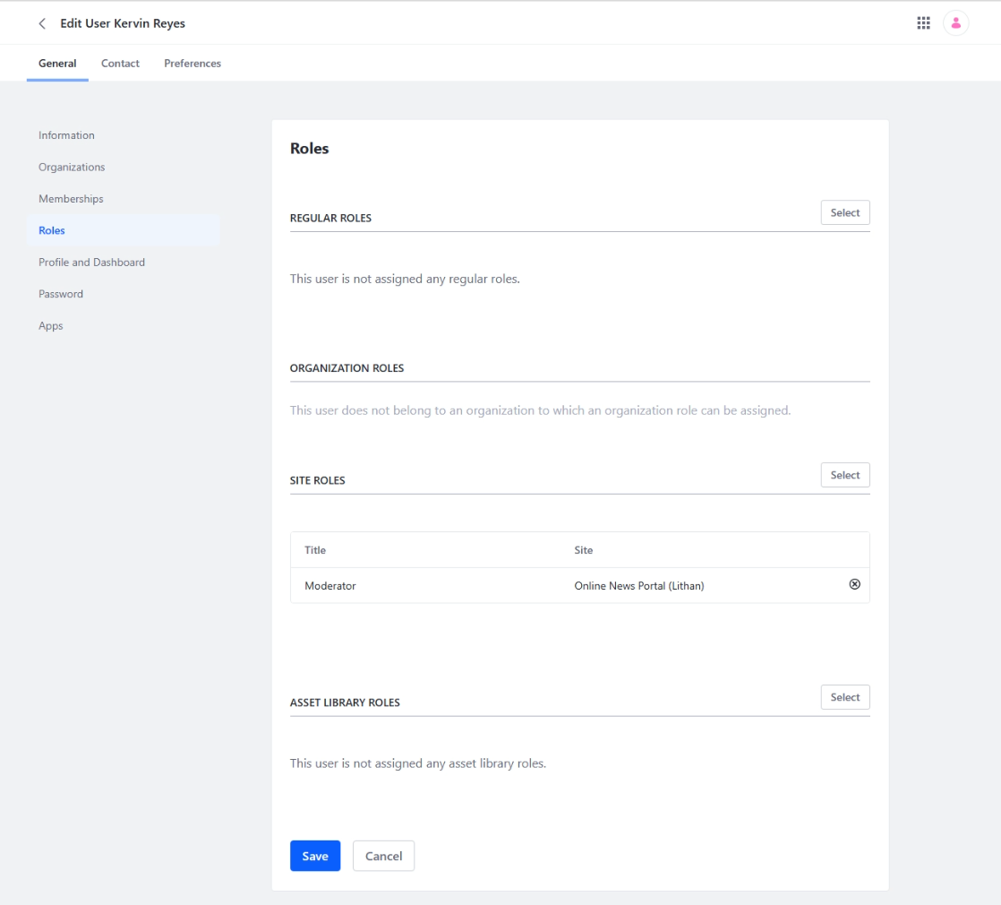

Administrator (Francis)

- Here’s the full information for the Administrator  
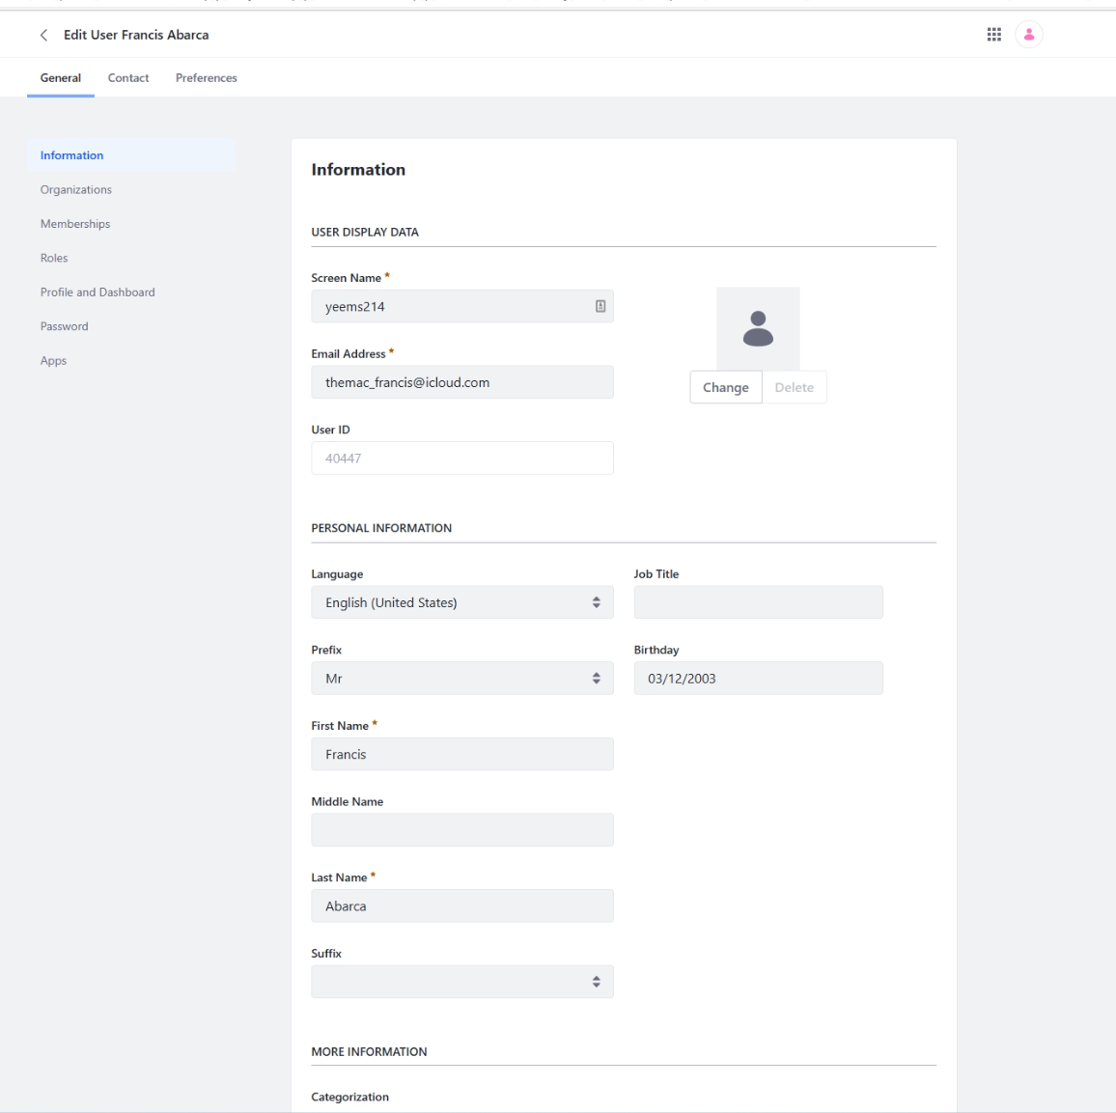

- Go to Memberships then assign the admin to its designated site and save.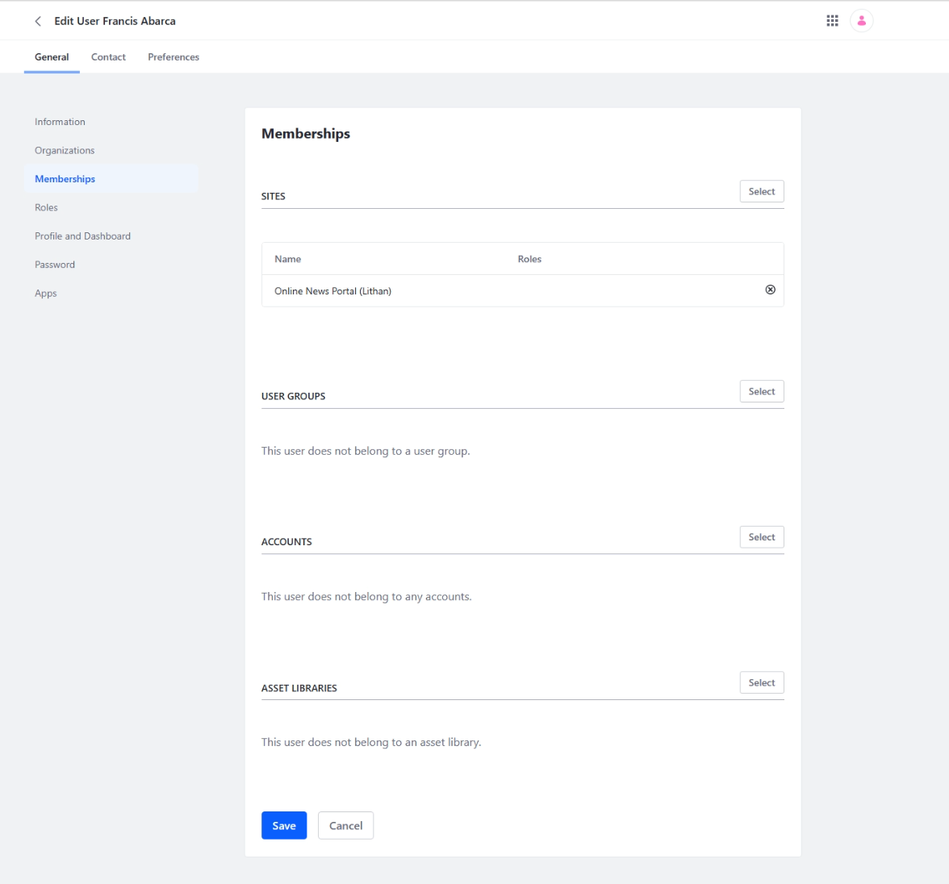

- Go to Roles then inside Site Roles, click Select and set it to Administrator.  
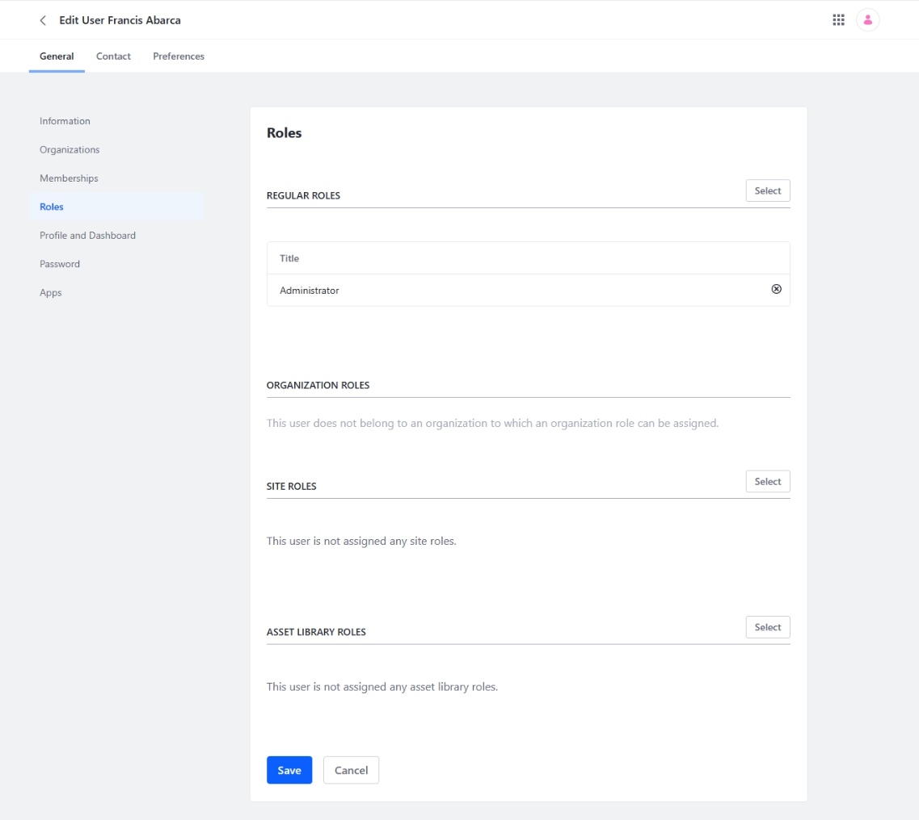

- All Users 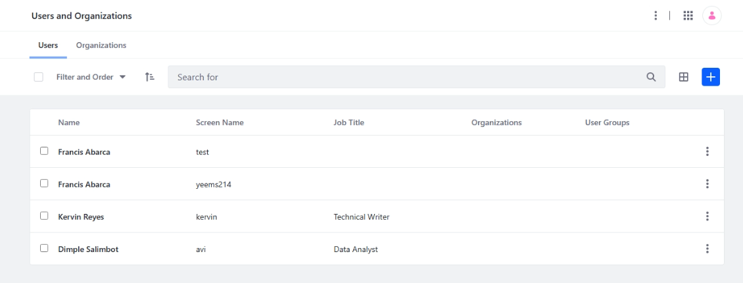

1. Check different access rights between Administrator, Site Administrator, and Moderator.

